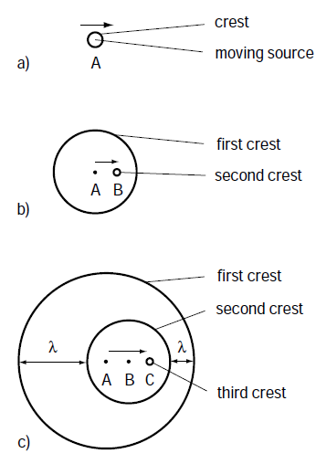
Doppler’s Effect
(Video: RedShift.wmv (Use first 30seconds only))
(Simulation: Doppler.html)

When the medium doesn’t change, speed of sound doesn’t change

v = ƒ λ → ƒ = 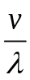

When a source of sound approaches an observer, wavelength _____________ and the observed frequency _____________

When a source of sound moves away from an observer, wavelength _____________ and the observed frequency _____________

Note 1: the moving speed of the sound source must be a ________________________ of the speed of sound.
Note 2: the moving direction of the sound source must have a ______________________ that is moving towards the observer.

For a stationary observer, the mathematic relationship between the source’s frequency and the observed frequency is:
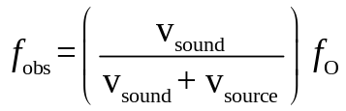

f_{obs} : observed frequency [Hz]
f_{O} : frequency from the sound source [Hz]
v_{sound}: sound speed [m/s]
v_{source} : moving speed of the source [m/s] (Note: + when moving away / − when approaching)

Example 1: A hunter blowing a 210Hz horn is walking at a speed of 0.5m/s towards a stationary animal. What is the observed frequency by the animal? (Assume the speed of sound is 330m/s)

Example 2: A police car is driving with a 450Hz siren turned on. With the temperature of air at 22°C, a stationary observer observed a frequency of 423Hz.
a) Is the police car moving towards or away from the observer?

b) What is the speed of the police car?

Sound Barrier and Sonic Booms
(Simulation: Doppler.html with setting higher than mach 1)
(Video: Supersonic flight and Sonic Boom.avi)
When an object travels through a medium at a speed ______________________ than the speed of sound in the medium, the sound barrier is __________ and a ______________ is formed. The _________ you hear is called a sonic boom

